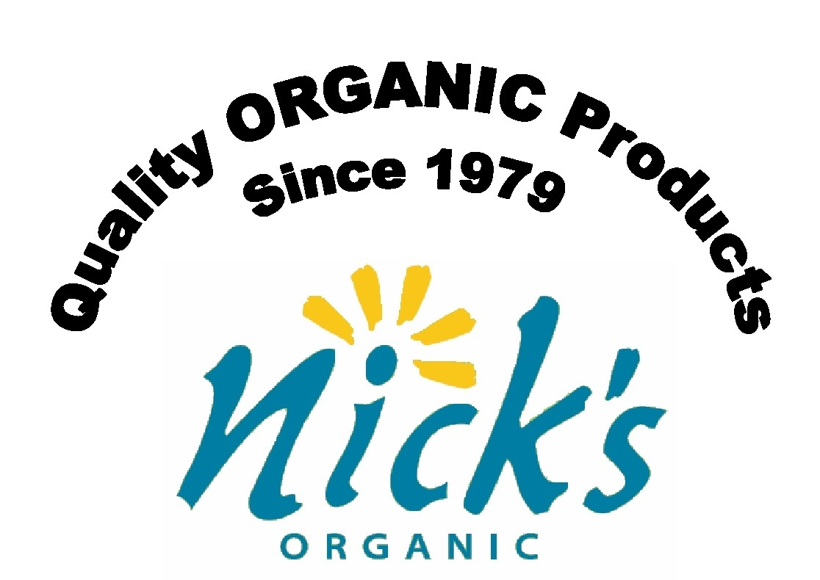
Nick’s Organic Farm
Frequently Asked Questions (FAQ) on Feed
ON THE FEED ITSELF:
Q: Is your feed certified organic?
A: Yes.
Q: What kind of feed do you make?
A: We regularly grind feed for chickens (broiler mash and layer mash) and turkeys. We can also custom-grind other feeds. For custom-grinding, we need a minimum of a one-ton order.
Q: What’s in your poultry feed?
A: Our certified organic poultry feed contains corn, roasted soybeans, barley, alfalfa hay, lime (which provides calcium), ground oyster shells (for layers), fishmeal (for broilers) and a mineral mix.
Q: Where do you get the grain in the feed?
A: We grow all our own organic grains on our farm. If we ever had a crop failure, we would buy some organic grains from other local organic farms.
Q: Where do you get the minerals in the feed?
A: We use minerals and fishmeal from Fertrell in our feed. (We are also a dealer for Fertrell.)
Q: Does your feed contain grit?
A: No. Our feed does not contain grit. You can buy your own grit separately, if you feel your birds do not get enough by foraging around on the ground.
Q: How often do you grind your feed?
A: We grind chicken and turkey feeds on a monthly basis.
ON THE COST OF THE FEED:
Q: How much does your certified organic poultry feed cost?
A: Prices change with market conditions. Also, for bulk, un-bagged orders there is a $20 refundable deposit if we supply you with a one-ton tote. For current prices click here.

ON ORDERING THE FEED:

Q: How do I place an order?
A: Email us at nicksorganicfarm@comcast.net or call (301) 983-2167 and let us know what you want to order. To establish an account, we need your name, address, phone numbers, and email for the notices. Let us know if you want to pick up at the Buckeystown or Potomac location.
We send out an email notice around the 20th of each month to remind you to place your order. Reply to this email only if you want to order. If you have a standing order for the same amount of feed each month, you do not need to reply—unless you are changing your order.
Once you have placed an order, you should receive an email from us during the first ten days of the next month saying you order is ready for pick up. If you have not heard from us by the 10th of the month, please contact us. Please reply to our pick-up notice so we know you received it. If you do not have email, we will call you when your order is ready.
We accept cash or checks when you pick up our feed.
Q: When should I order?
A: We take orders from the 20th-25th of each month. We try to accommodate first-time customers' orders that come outside of our regular ordering cycle. Most of our customers place a standing order. We are happy to change your standing order when you advise us.
Q: How much should I order?
A: There are no hard and fast guidelines here. It depends on how many birds you have, how old they are, how much free range or pasture they have, how efficiently they eat from the feeder, what the weather is like, etc. When you are first starting out, simply give it your best guess and then add a half bag or a full bag or two. If you think you need one bag for a month, order a bag and a half. Remember young birds eat more as they grow. If you think you need ten bags, order twelve, etc. We never have problems with customers ordering too much feed. They simply use the feed in the next month. (See “How to Store,” below.) However, we do receive many urgent requests for more feed from customers who are running short before the next order is ready. Because we tend to grind feed only once a month, we cannot always fill these emergency orders.
ON PICKING UP THE FEED:
Q: When do I pick up my feed order?
A: Your order will be ready to pick up within the first 10 days of the month following your order. You will be notified by email when it is ready, as noted above in the section, “How do I place an order?”
Q: Where do I pick up my feed order?
A: Your order will be ready at the location you have selected: the Buckeystown Farm at 2733 Buckeystown Pike, Adamstown, MD 21710, or at the Potomac Farm at 8565 Horseshoe Lane, Potomac, MD 20854. Before your first pick up, please call Nick or Jale 301-983-2167 or send us an email so we can tell you how to find your feed and invoice and where to put your payment.

Q: Should I return my empty feed bags?
Yes, we ask that you return your clean, empty feed bags so they can be re-used. Try to pull the string out of the top of the bag without damaging, ripping or cutting the bag. See next question.
Q: How do I open the feed bag?
There are two methods to pull the string out of the top of the feed bag without damaging the bag.
First is the fool-proof method. Stand the bag upright. On one side of the bag you will see a looped row of string stitching; this is the “rough” side. On the other side you will see one straight row of string stitching; this is the “smooth” side. Cut the string that is hanging off the bag so that it is flush with the edge of the bag on both edges of the bag. Now, pull the cut end of the string from the smooth side. If this does not work, try the other edge cut end. Most often you will have to “start” the pull by pulling the cut end out of one or two of the loops holding it on the rough side. Then pull the string and the bag stitching will unravel.
Second is the precision method. Stand the bag upright with the rough side of the stitching facing you. Then cut the LEFT side of the dangling stitching very flush with the edge of the bag. (This action cuts the loop of the lock stitching.) With your finger nails or the point of a knife or scissor, unthread (pull) the cut end from the smooth side so it comes out of the loop on the rough side. Then pull the string from the smooth side and the stitching should unravel.
Q: What should I do if I can’t pick up as scheduled?
A: If you can’t pick up your order within seven days of being notified, please email us at nicksorganicfarm@comcast.net or call Nick or Jale at the Potomac Farm at (301) 983-2167 to advise us when you can pick up. Otherwise, your feed may be gone—fed to our birds. Call back if no one answers.
Q: Do I have to load my own bags?
A: Yes, you will have to load your own bags. You can order 25 pound bags that are easier to lift. Remember that layer feed is in white bags; broiler feed is in blue bags. We load bulk orders onto your truck with our equipment. We can only do bulk loading at the Buckeystown location.
ON FEED STORAGE:
Q: How should I store my feed?
A: You should store your feed so it will not attract mice. A metal garbage can with a lid is fairly secure against mice, insects, rain and moisture. Plastic garbage cans are less secure against mice.
Q: How long can I store my feed?
A: In the warmer months (May to September), feed can be kept easily for 30-60 days. Try to keep it cool (in the shade, in a basement, etc.) and dry. In the cooler months (October to March), feed can be keep for four months if it is kept dry and mainly below 50 degrees—below 40 degrees is even better. The cooler the feed, the longer it will keep. Freezing should not affect it. Try to keep it in an area where there will not be large temperatures swings (in the shade, in the basement or garage, in the barn, etc.) so as to avoid water condensation occurring from storing in a metal container.
ON OTHER PRODUCTS WE SELL:
Q: Do you sell corn, barley, hay or straw?
A: Yes. When we have it to spare, we sell whole corn in a 50-pound bag, and whole barley in a 48-pound bag. When available, we also sell hay and straw.
Q: Do you sell Fertrell minerals and fertilizer?
Yes. We are a dealer for Fertrell minerals and fertilizers. If there are items you wish to order, contact us as soon as you can (do not wait until the end of the month), because we do not stock most items and it will take time for your order to arrive. To view a current listing of Fertrell products, go to their website: www.fertrell.com/index.html.
Q: Do you sell fishmeal and sea kelp?
A: Yes, we sell fishmeal and sea kelp from Fertrell. We sell fishmeal for about $1.60/lb. This price can vary slightly from month to month. Call for prices on kelp.
ON THE USE OF THE FEED FOR CHICKS:
Q: What should I feed young and developing chickens?
A: For the first four weeks, feed chicks a starter mix of broiler mash plus 10% fishmeal, which you can mix yourself—five pounds of fishmeal into 50 pounds of broiler mash, or small amounts in a five gallon bucket. (Note that we sell fishmeal.) The extra fishmeal is added to increase the protein in the feed during the early stage of growth.
After four weeks, keep broilers on straight broiler mash. Feed pullets (young laying hens) straight broiler mash only until they are about 12 weeks old, and then feed them layer mash and broiler mash mixed together until the birds reach 16 weeks. Start out with a larger percentage of broiler mash in the mix and finish with a larger percentage of layer mash over this four-week period. Then begin feeding only layer mash. Hens usually start laying eggs sometime between 18 and 20 weeks of age. The first “pullet eggs” will be smaller than normal, but after a few weeks the hens should be laying full-size eggs.
Q: What should I feed my young and developing turkeys?
A: Feed young turkeys broiler mash plus 20% fishmeal (10 pounds of fishmeal to 50 pounds of broiler mash) for the first 4 weeks, then 10% fishmeal for the next four weeks, then straight broiler mash.
Q: Where do I get the fishmeal?
A: We sell the fishmeal for about $1.60/lb (prices may vary).
FOR OTHER QUESTIONS NOT IN THIS FAQ:
Q: Who do I contact if I have questions?
A: Nick or Jale at Nick’s Organic Farm at 301-983-2167, nicksorgaicfarm@comcast.net, or see our website at www.nicksorganicfarm.com.

